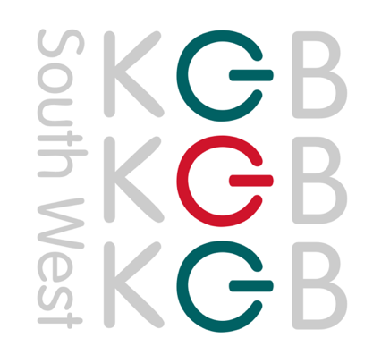

KGB Cleaning Southwest Ltd

Professional and reliable contract cleaning and support services focused on the education sector for 15 years.

About Us

We are a family run business working across the South of England, with the knowledge & experience to fully meet the core requirements of CPC members.

Providing a high-quality, innovative, and sustainable service to a broad range of educational clients.

We offer additional services, including pest control, feminine hygiene, and window cleaning through our reputable partners.

KGB has the following accreditations:
- ISO 9001: 14001: 45001
- Safe Contractors
- CHAS

We build solid relationships with our customers, proven by 90% of our customers extending their contracts with us.

Knowledge Growth and Belonging are our core company values which underpin our commitments to our clients.

New award for a multi-site trust in Bristol
We were delighted to have been awarded a new contract recently through the CPC framework for a multi-site Academy Trust in Bristol of 9 schools

Key Contacts
Julie Ellis – Account Manager – Julie.Ellis@kgbsouthwest.com
Sarah Claughton – Business Development -Sarah.Claughton@kgbsouthwest.com

